Pre-Requisites

Deep Learning Fundus Image Analysis for Early Detection of Diabetic Retinopathy

Team ID: PNT2022TMID37928

1. Anaconda navigator:

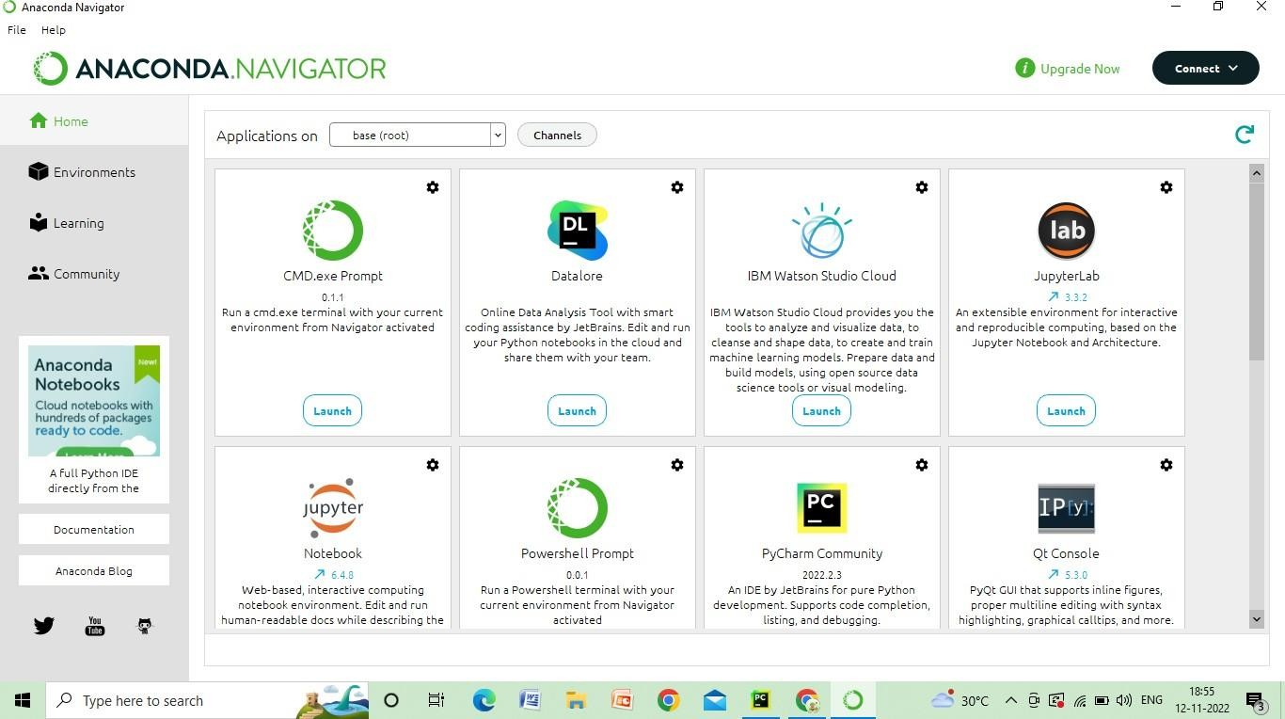

1. Pycharm:

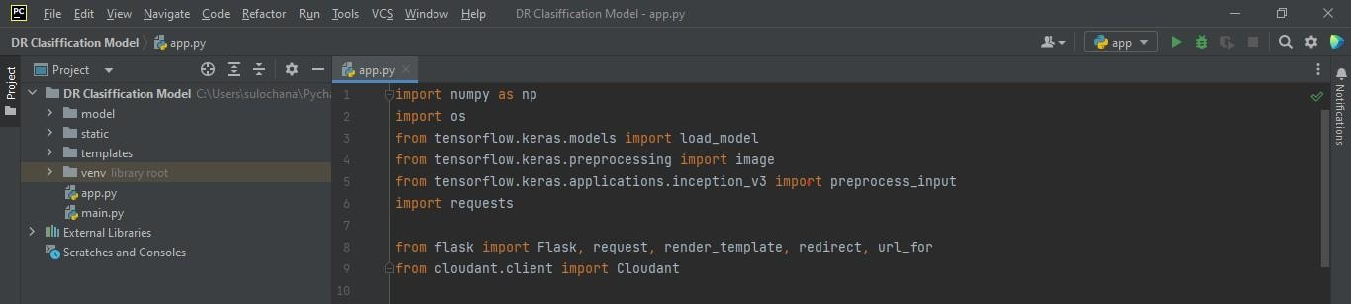

1. Numpy
2. Pandas
3. Tensorflow==2.3.2 6. keras==2.3.1

7. Flask